**LIST OF CONTENT**

1. npm
2. npm-init
3. installing and uninstalling packages
4. package.json
5. Creating package.sjon file

**npm**

* **NPM (**Node Package Manager**)** is a package manager for Node.js applications.
* It is a command-line utility that makes it easy to install ,manage and share packages of node.js code.
* NPM is the default package manager for node.js and it allows developers to easily install and manage dependences for their Node.js projects.
* NPM provides a central repository of packages, which developers can browse and search to find the packages they need.Packages can also be published to the repository ,making it easy for other developers to discover and use them.
* Package Management | Dependency management | Version Conteol | Command Line Interface | Publishing and sharing packages.

**npm-init**

* The npm init command is used to initialize a new or existing npm package. it creates a Package.json file that contains important information about the package, such as its name, version, dependences and other metadata.
* When an initializer is specified ,it installs the corresponding npm package named

**Create-<initializer> using npm-exec**

**Useful Commands**

* **npm –v (returns a version of the node )**



* **mkdir myreact-app (here mkdir means create a folder which name is myreact-app)**

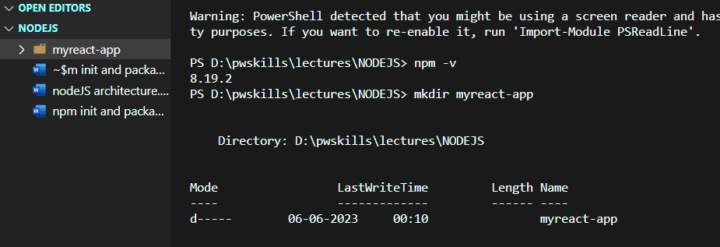

* **npm init react-app myreact-app**

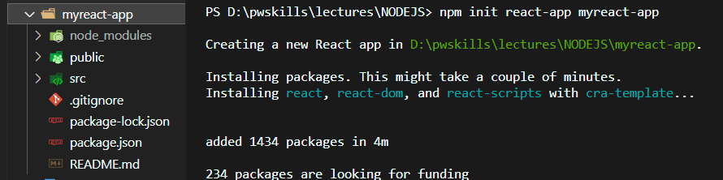

* **Using cd foldername we can change the path**

**npm init esm –yes (usig this command we don’t want to write address or location)**

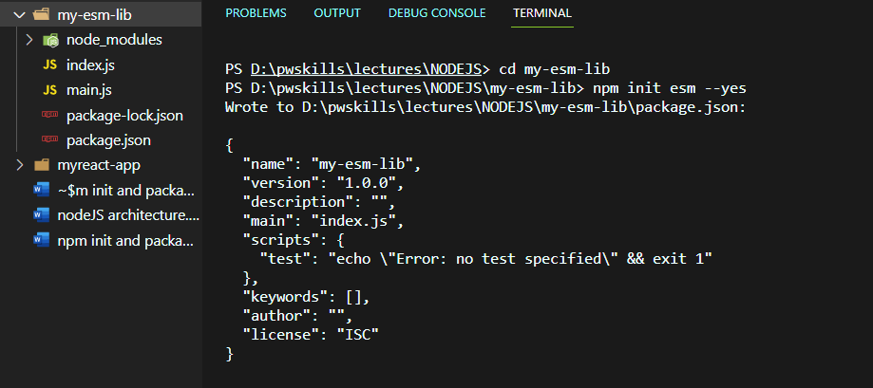

* **Using mkdir projects (projects folder created then)using cd ..** exit from the folder and **npm init –y** creates package.json file automatically

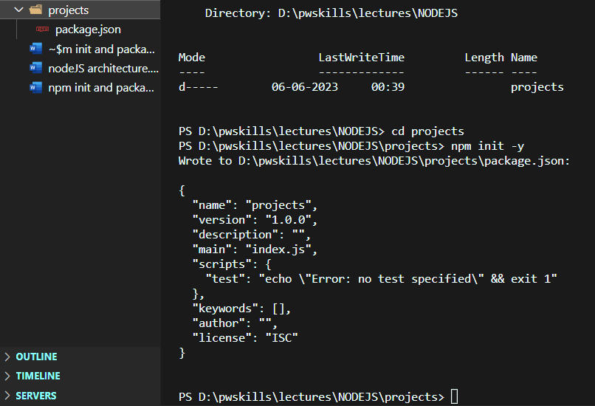

**Name, author, dependences etc details shows here**

* Using  **npm init -w packages/p1 (**in workspace projects folder one packages/p1 is created**)**

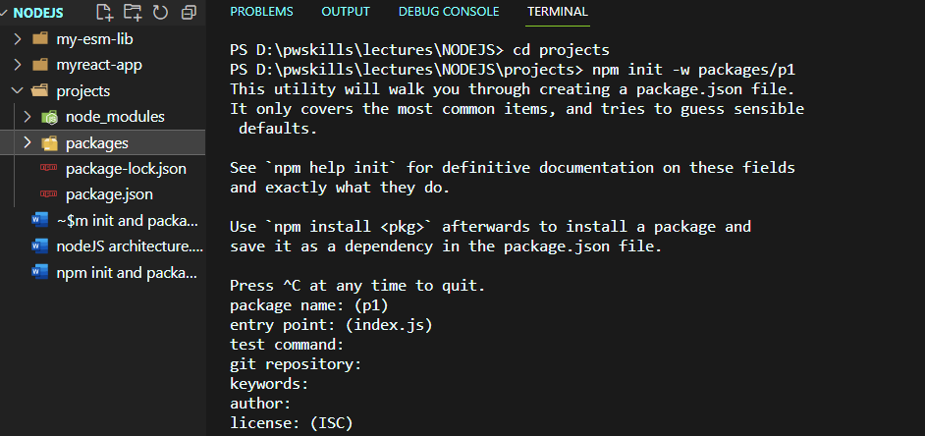

* **npm init -w packages/my-react-app react-app my-react-app**

using this command one react-app is created in the packages folder

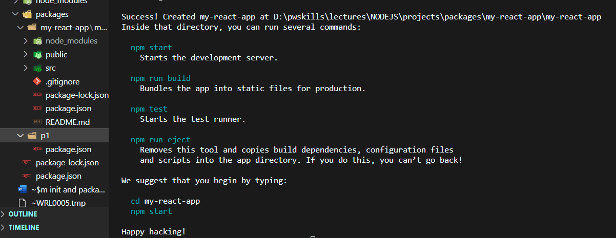

* using **npm search ‘react’**

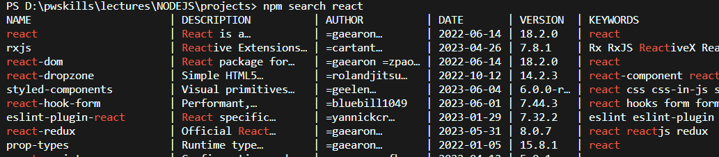

* EXAMPLES
* To Create a new React-Based project using create-react-app:

**npm init react-app myreact-app**

* To generate a package.json file without any user input:

**npm init –y**

* To generate a plain old package.json using legacy init:

**npm init**

* To generate a package.json file without using user input:

**npm init esm –yes**

* To create a new workspace within a project:

**npm init -w packages/p1**

* To create a new React-Based workspace within a project:

**npm init -w packages/my-react-app react-app my-react-app**

**Installing packages in node**

npm install package_name

npm install package_name –save

npm install package_name –save-dev

npm install package1 package2 package3

* Installing typescript in current project

Command :-- **npm install typescript** | **npm install typescript –save**

**Here it will shows in package.json in dependences object it will save**

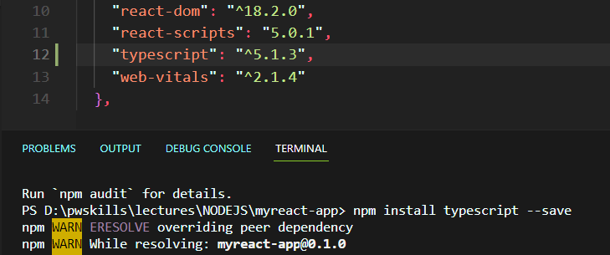

* We can install particular version package dev dependence

**npm install react-scripts --save-dev**

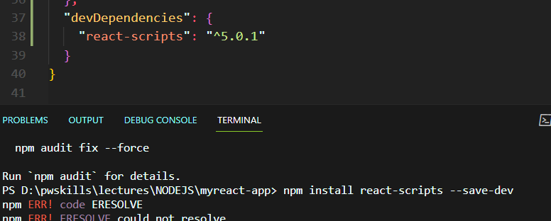

**Uninstalling packages**

npm uninstall package_name

npm uninstall package_name –save

npm uninstall package_name –save-dev

npm uninstall package1 package2 package3

**react package is uninstalled**

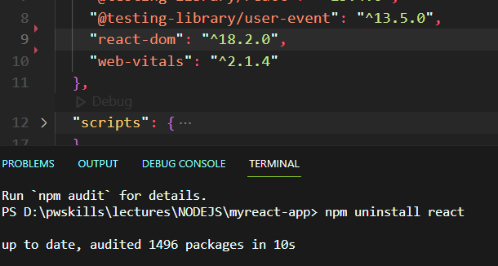

**PS D:\pwskills\lectures\NODEJS\my-project> npm init**

**This utility will walk you through creating a package.json file.**

**It only covers the most common items, and tries to guess sensible defaults.**

**See `npm help init` for definitive documentation on these fields**

**and exactly what they do.**

**Use `npm install <pkg>` afterwards to install a package and**

**save it as a dependency in the package.json file.**

**Press ^C at any time to quit.**

**package name: (my-project) my-project**

**version: (1.0.0) 1.0.1**

**description: this is my project which is used to handle pw node js dependencies**

**entry point: (index.js) index.js**

**test command: npm run test**

**git repository:**

**keywords: vandan raval,pw skills**

**author: vandan raval**

**license: (ISC)**

**About to write to D:\pwskills\lectures\NODEJS\my-project\package.json:**

**{**

**"name": "my-project",**

**"version": "1.0.1",**

**"description": "this is my project which is used to handle pw node js dependencies",**

**"main": "index.js",**

**"scripts": {**

**"test": "npm run test"**

**},**

**"keywords": [**

**"vandan",**

**"raval",**

**"pw",**

**"skills"**

**],**

**"author": "vandan raval",**

**"license": "ISC"**

**}**

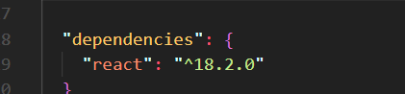

PS D:\pwskills\lectures\NODEJS\my-project> npm install react --save

added 3 packages, and audited 4 packages in 3s

found 0 vulnerabilities

PS D:\pwskills\lectures\NODEJS\my-project> npm install react-scripts --save-dev

